- Git Setup https://confluence.atlassian.com/bitbucket/set-up-git-744723531.html
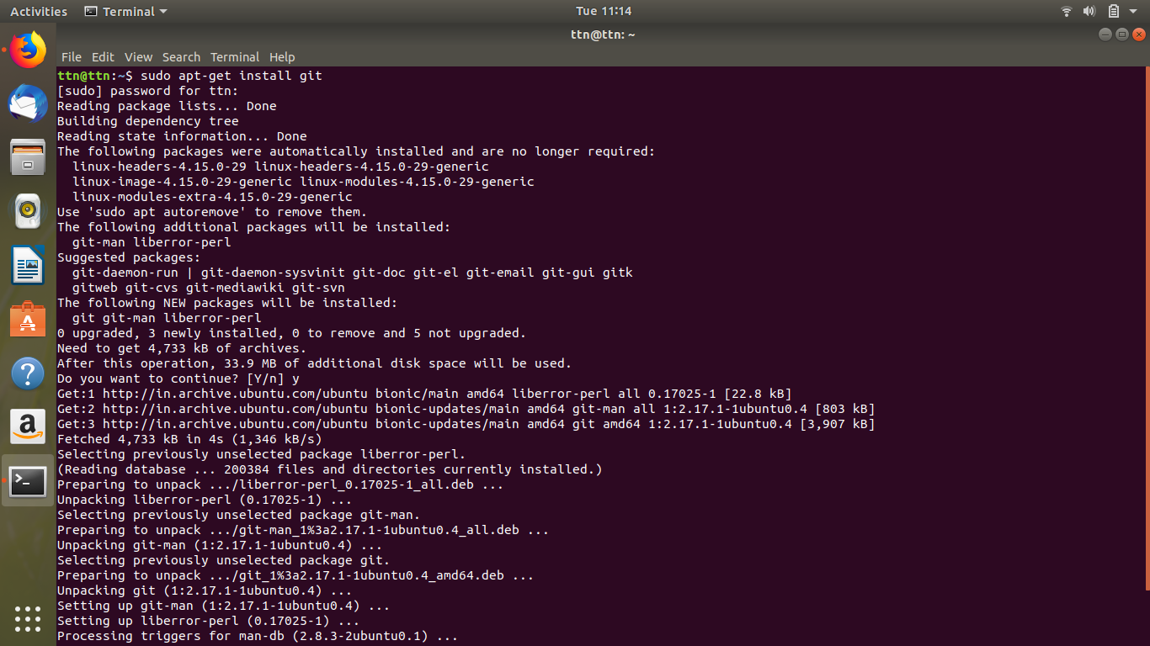
- Initialize a Git Repository
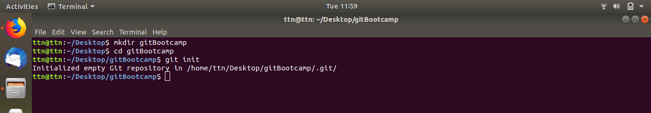
- Add files to the repository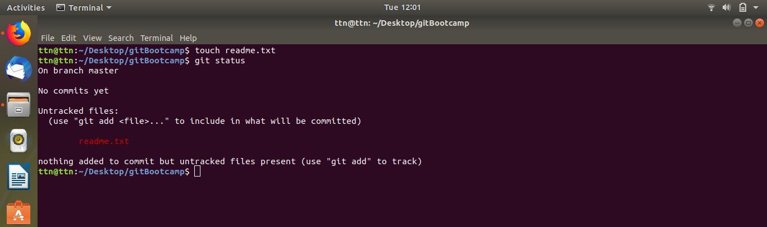

- Unstage 1 file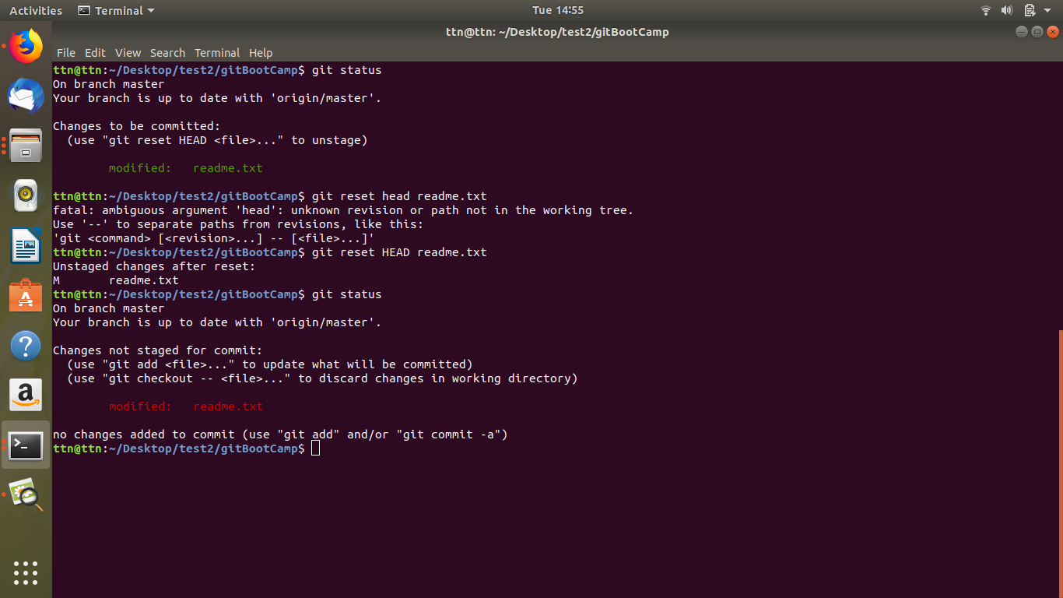

- Commit the file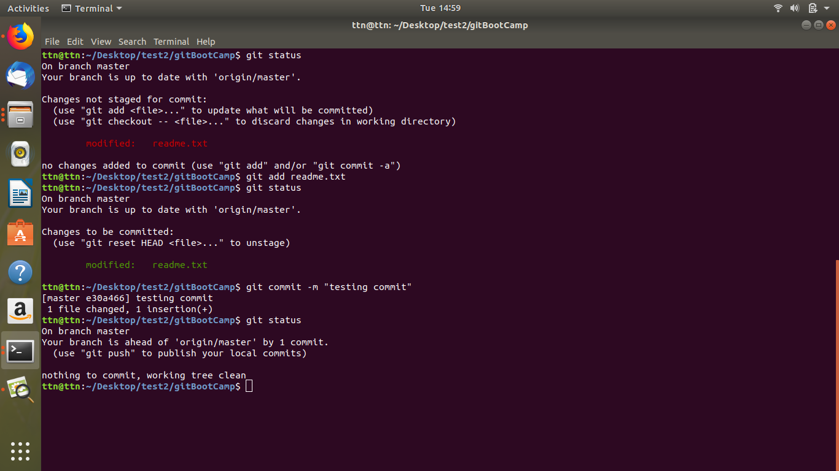
- Add a remote
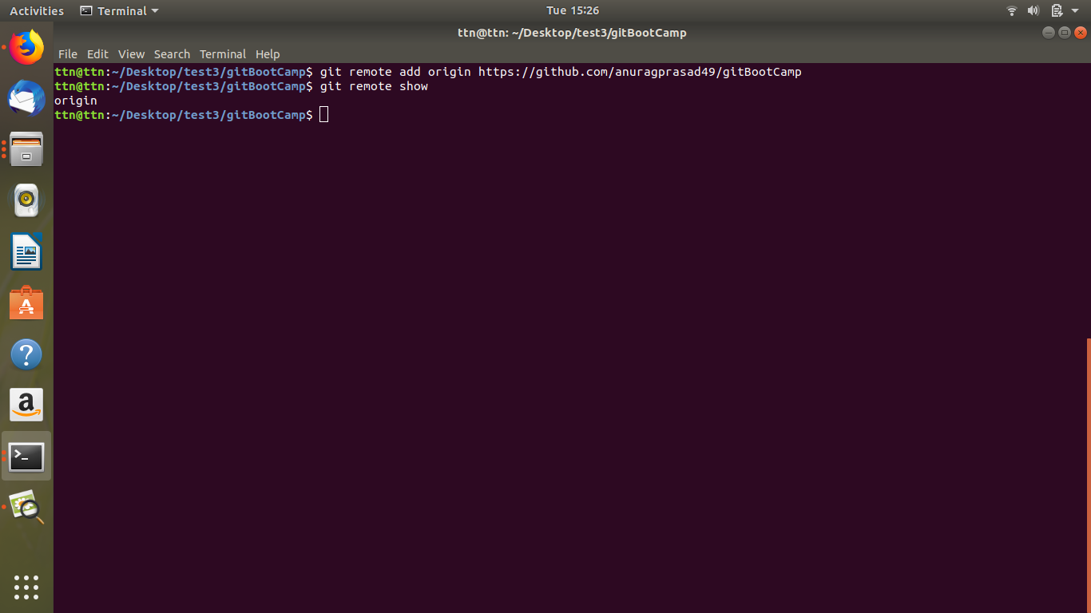
- Undo changes to a particular file
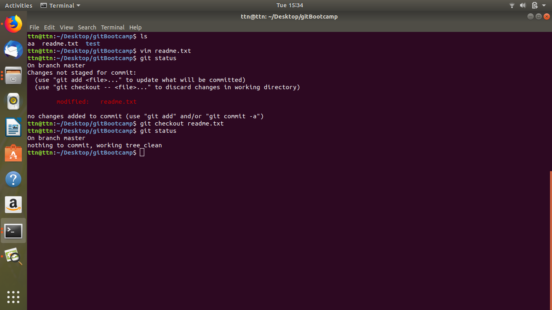

8. Push changes to Github

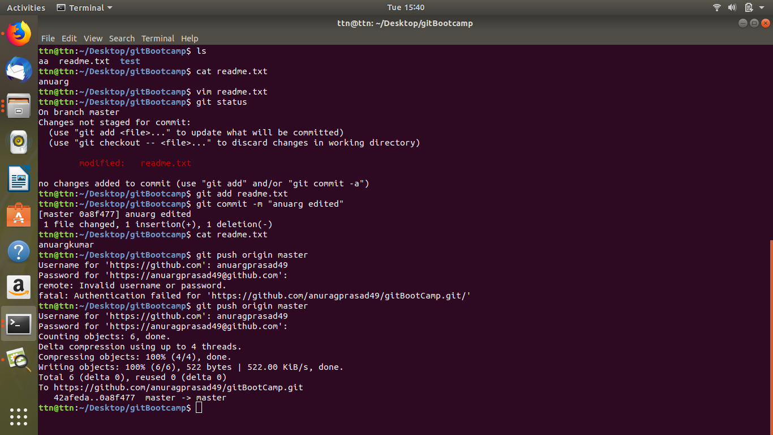

- Clone the repository

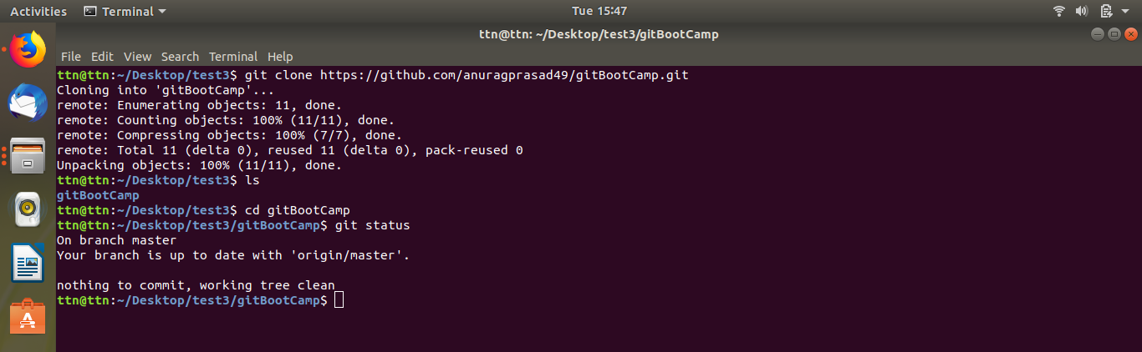

- Add changes to one of the copies and pull the changes in the other.
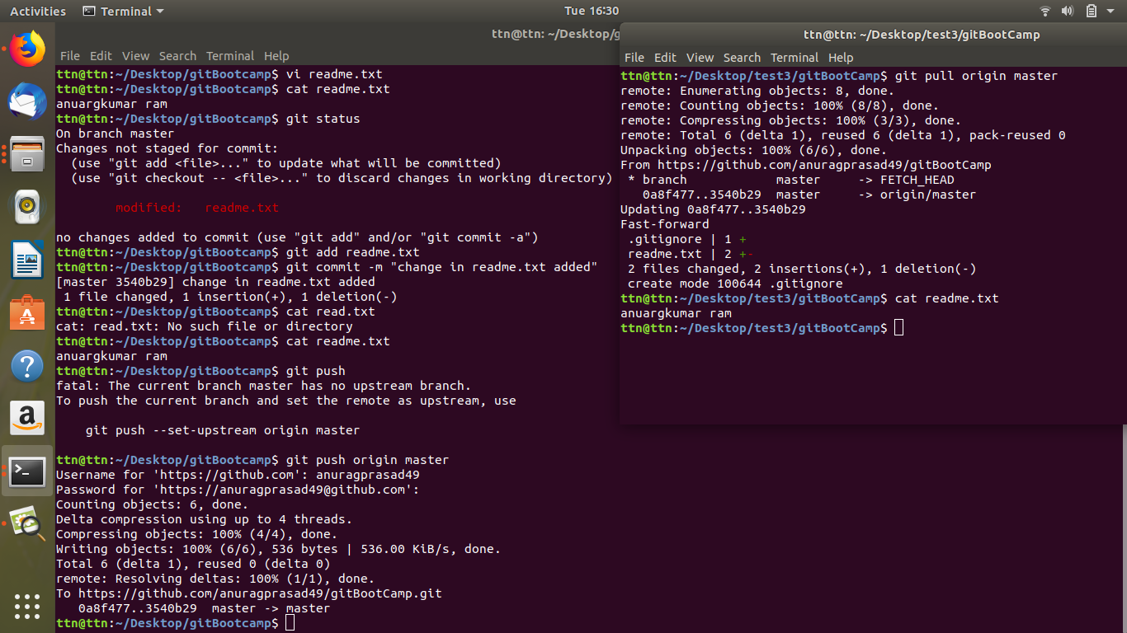

- Check differences between a file and its staged version
The file which is added by us in repository by using touch are unstaged file and we have to add it to staged by using git add filename becuse if we want to commit the changes the all file should be staged
- Ignore a few files to be checked in

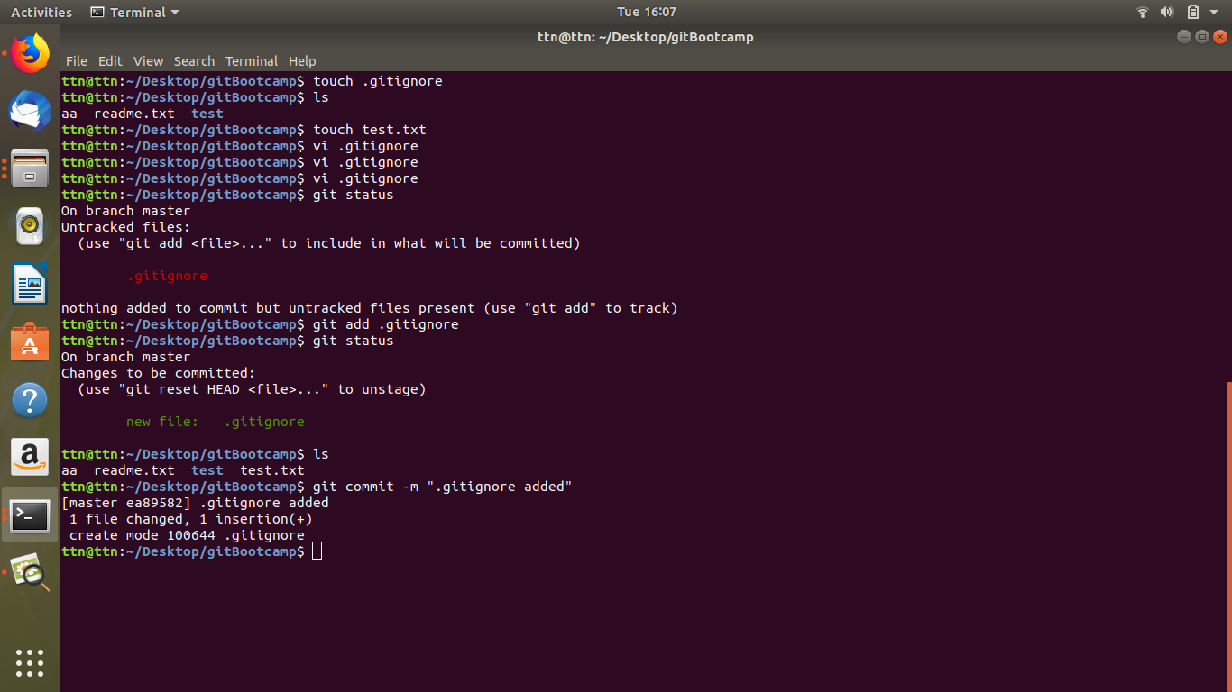

- Create a new branch.

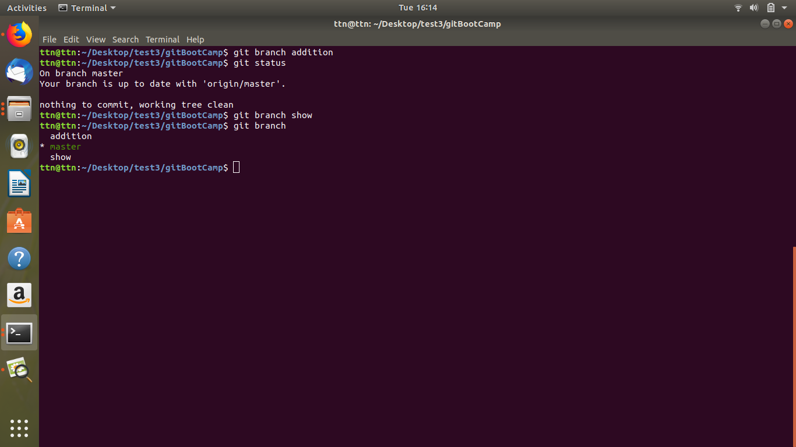
- Diverge them with commits
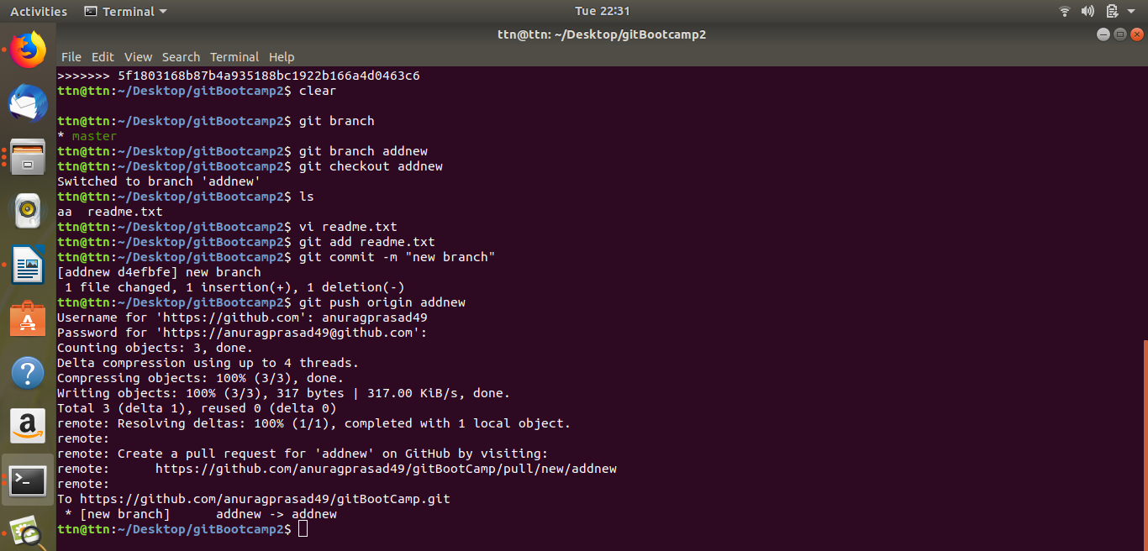

- Edit the same file at the same line on both branches and commit

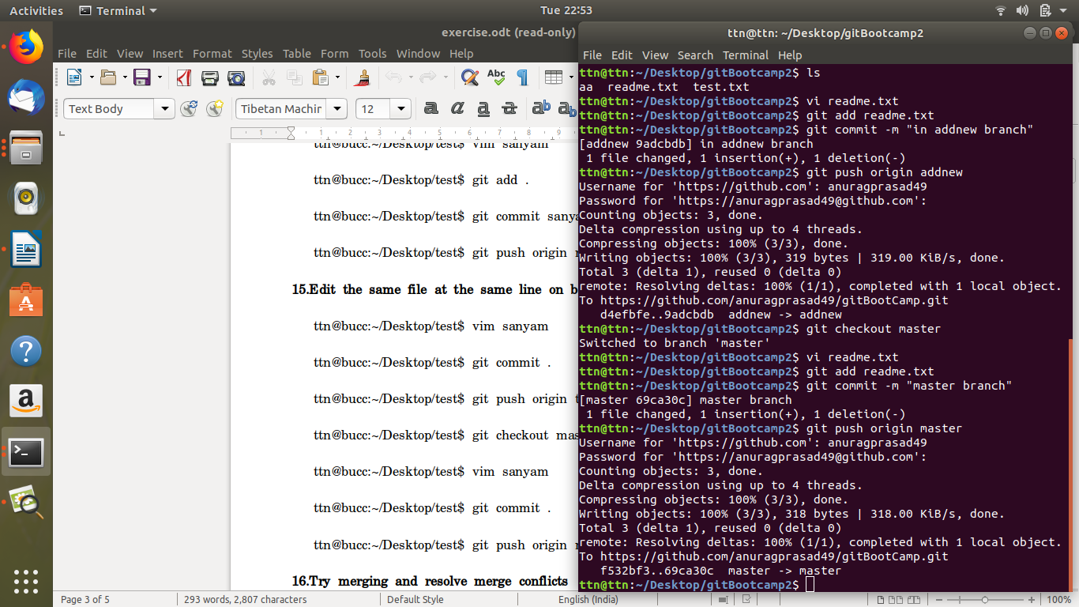

- Try merging and resolve merge conflicts

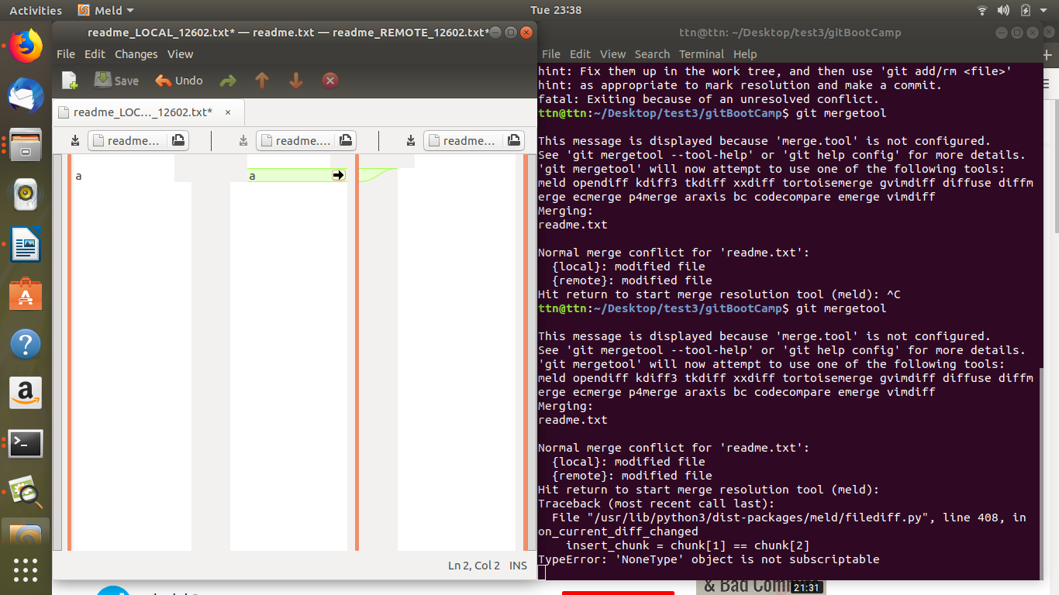
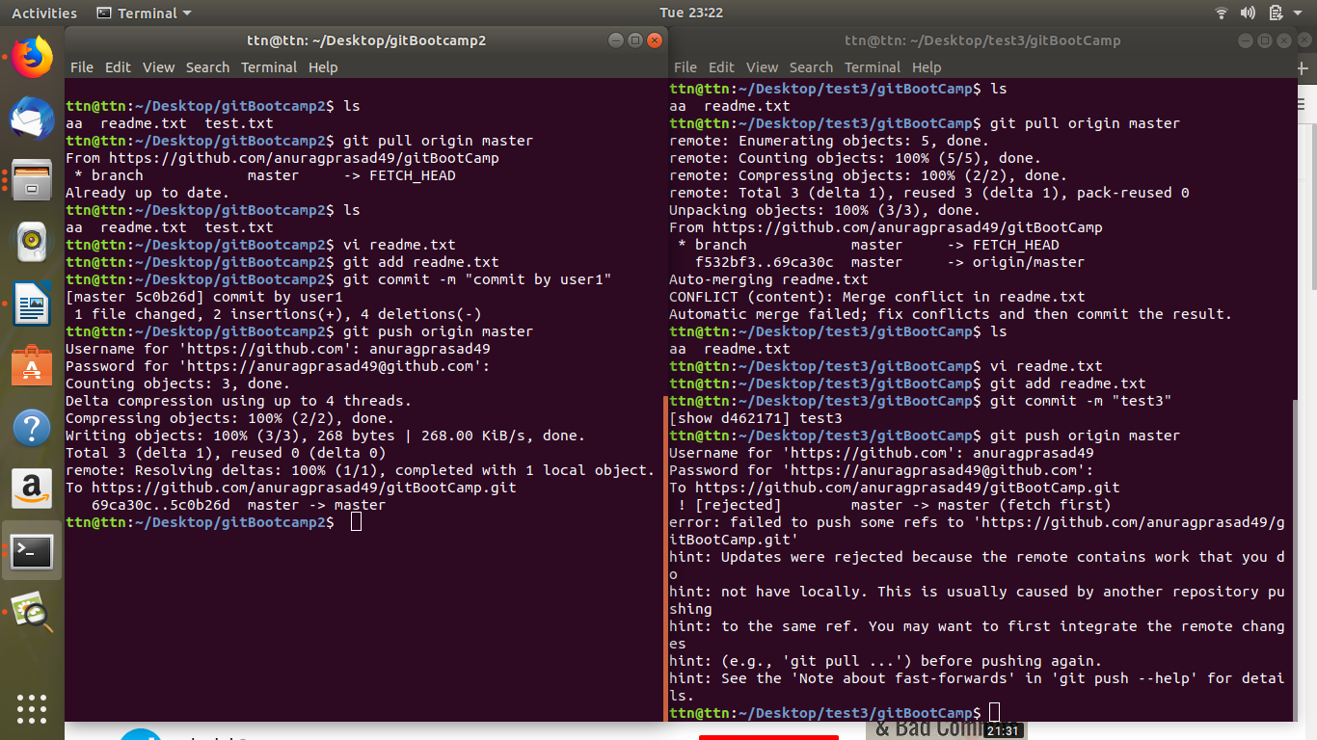

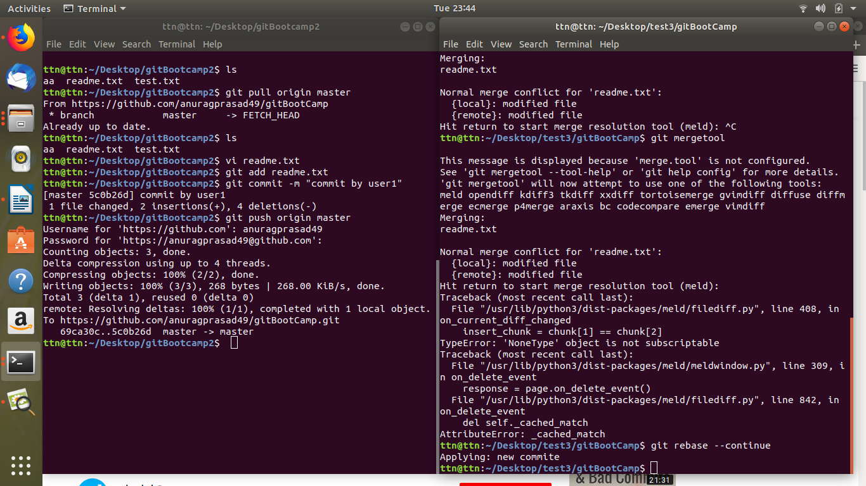

- Stash the changes and pop them

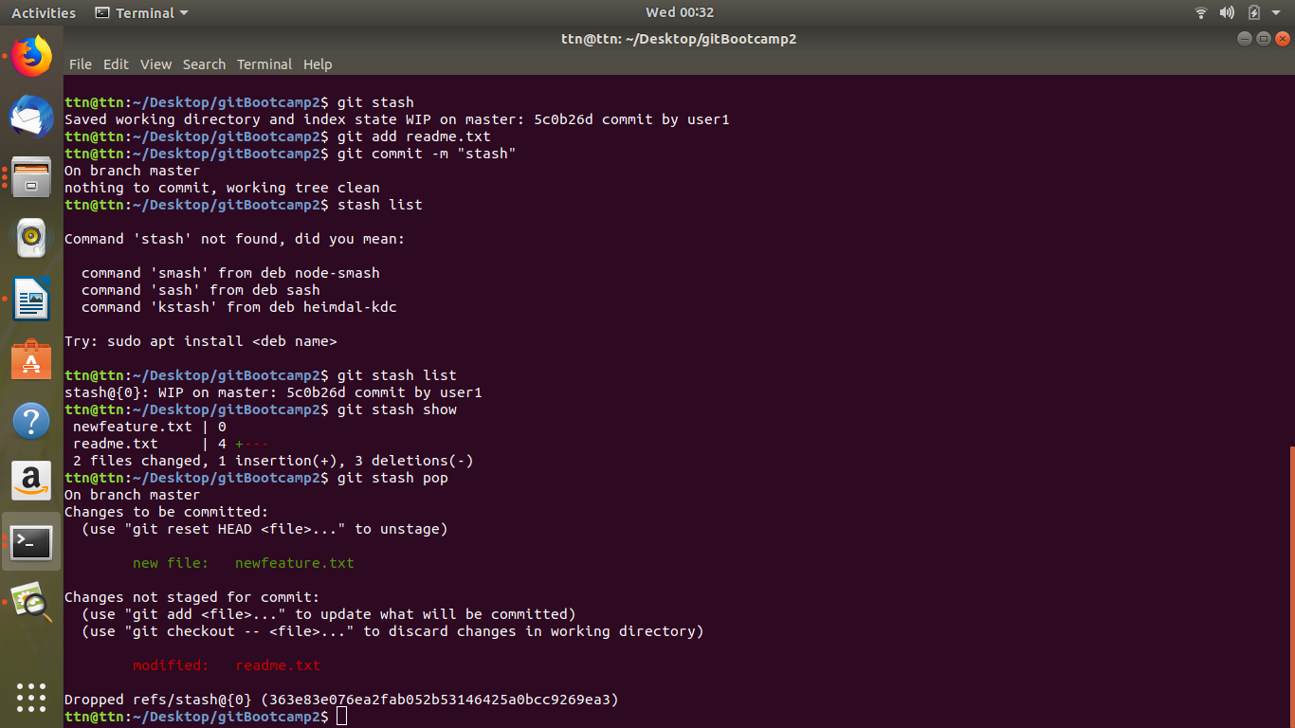

- Add the following code to your .bashrc file : color_prompt="yes"
parse_git_branch() {
git branch 2> /dev/null | sed -e '/^[^*]/d' -e 's/* \(.*\)/(\1)/'
}
if [ "$color_prompt" = yes ]; then
PS1='\u@\h\[\033[00m\]:\[\033[01;34m\]\W\[\033[01;31m\] $(parse_git_branch)\[\033[00m\]\$ '
else
PS1='\u@\h:\W $(parse_git_branch)\$ '
fi
unset color_prompt force_color_prompt
